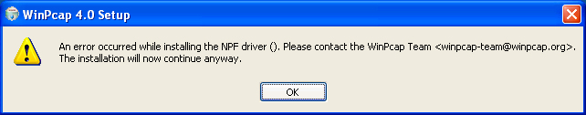
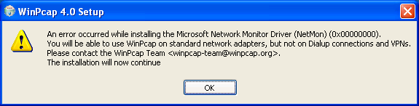

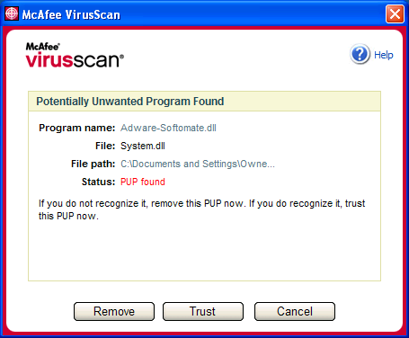
http://wireshark.osmirror.nl/download/win32/wireshark-setup-0.99.5.exe

