Agreement

between

Computec Media AG,
Dr. Mack Strasse 77, D 90762 Fuerth
(in the following named Computec)

and

XXXXXXXXXX
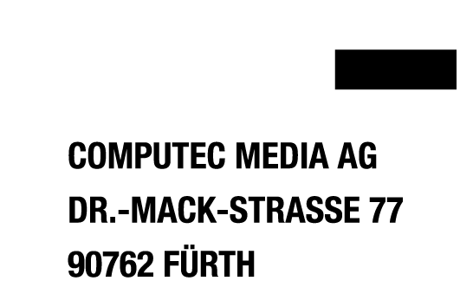
(in the following named Owner of the Copyright)

Preamble
Computec publishes software as demo-versions, full versions, slide shows and self-running trailers on CD-ROMs and DVDs along with its magazines. Referring to this Computec and the Owner of the Copyright make the following arrangement:

1. The Owner of the Copyright gives Computec the right to publish the product/products:

- XXXXXXX

on CD-ROMs/DVDs attached to its magazines and its online services in the form supplied by the Owner of the Copyright.

2. The Owner of the Copyright guarantees that he is qualified to distribute the rights mentioned under 1. and exempts Computec from the demands of third parties.

3. Both parties agree that they will not demand any compensation for the publishing of the software.

Fuerth, 29.07.2026

Juergen Melzer ________________________
Head of Department CD-ROM (stamp and Signature)
Computec Media (SH)

