Problem with the new version 0.10.0a compared with version 0.9.14

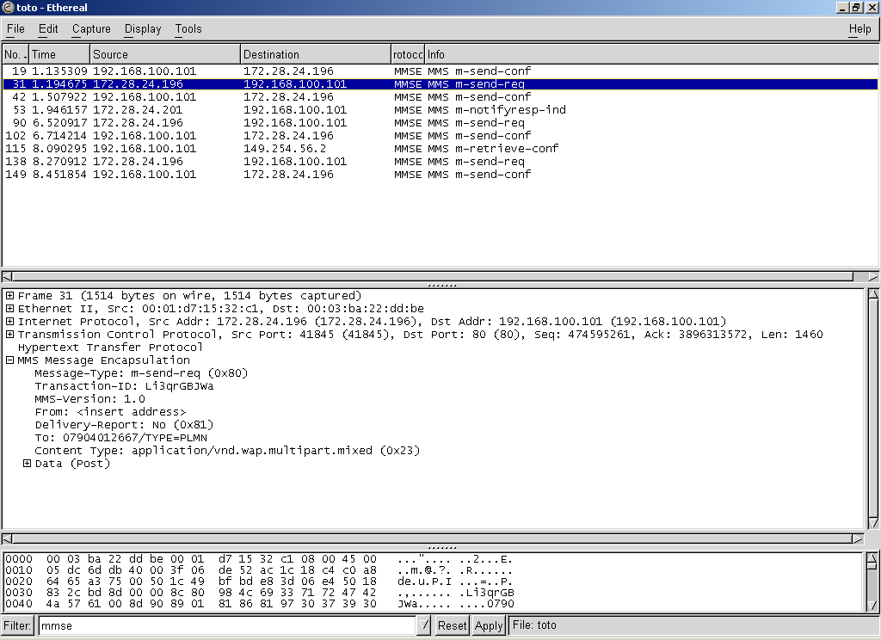

Snapshot with the older version 0.9.14 which shows all the “m-“ replies when the mmse filter is applied. The new version 0.10.0a, the m-send-req and m-notifyresp-ind are not seen at all. ( screenshot below) for the same snoop capture.
